* DLINK DFE-528TX/DFE-520TX 10/100MBPS LAN CARD

10BASE-T: 10Mbps (half-duplex), 20Mbps (full-duplex)  
100BASE-TX: 100Mbps (half-duplex), 200Mbps (full-duplex)

* DLINK DWA-525 PCI WIRELESS LAN CARD

Up to 150 Mbps wireless speeds

2.4GHz frequency band

Compatible with 802.11g and 802.11n wireless networks

* Hardware

32-bit PCI local bus

Low-profile bracket included

Detachable 2 dBi dipole antenna

* Wireless

Up to 150 Mbps wireless speeds

2.4GHz frequency band

Compatible with 802.11g and 802.11n wireless networks

* Operating Systems

Windows 2000 (SP4)

Windows XP (SP2 and above)

Windows Vista (32 or 64-bit)

Windows 7 (32 or 64-bit)

* Security

Strong WPA/WPA2 data encryption security

Wireless Protect Setup (WPS): wireless encryption at the click of a button

Configuration/Management

Quick setup wizard in 18 languages

D-Link Wireless Manager for easy access to frequently accessed networks

* LINK TL-WN851N 300MBPS WIRELESS N PCI ADAPTER

**Wireless N speed up to 300Mbps makes it ideal for video streaming, online gaming and Internet calls**

**MIMO technology with stronger signal penetration strength, wider wireless coverage, providing better performance and stability**

**Easily setup a highly secured wireless link with QSS™ (Quick Security Setup)**

* What This Product Does

Wireless N PCI Adapter TL-WN851ND allows you to connect a desktop computer to a wireless network and access high-speed Internet connection. Comply with IEEE 802.11n, they provide wireless speed up to 300Mbps, which is beneficial for the online gaming or even HD video streaming.

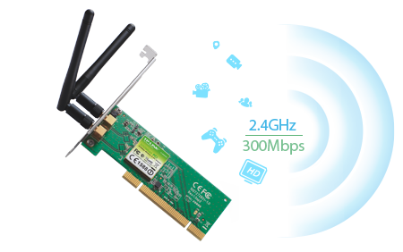

* Wireless N – Speed & Range

MIMO (multiple input, multiple output antennas) technology, it shows more excellent abilities of mitigating data loss over long distances and through obstacles in a small office or a large apartment, even in a steel-and-concrete building. Above all, you could easily pick up the wireless network during long-distance connection where legacy 11g products may not!

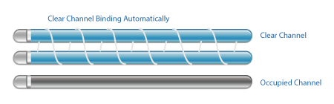

* CCA Technology – Stable Wireless Signals

Clear Channel Assessment (CCA) automatically avoids channel conflicts using its clear channel selection feature and fully realizes the advantages of channel binding, greatly enhanced the wireless performance.



* WPA / WPA2 Encryptions

WPA/WPA2 encryption standards ensure your wireless connection is safe from intruders.



* **Easy Setup**

Either using the optimized user interface and setup wizard or the CD (included) setup wizard will allow you to get ‘online’ quickly and easily.

* LINK TL-WN881ND 300MBPS WIRELESS N PCI EXPRESS ADAPTER

**Wireless N speed up to 300Mbps makes it ideal for video streaming, online gaming and Internet calls**

**MIMO technology with stronger signal penetration strength, wider wireless coverage, providing better performance and stability**

**Easily setup a highly secured wireless link with WPS™ (Wi-Fi Protected Setup)**

**What This Product Does**

Wireless N PCI Express 2.0(x1) Adapter TL-WN881ND allows you to connect a desktop computer to a wireless network and access high-speed Internet connection. Comply with IEEE 802.11n, they provide wireless speed up to 300Mbps, which is beneficial for the online gaming or even HD video streaming.

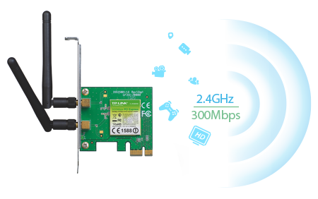

**Wireless N – Speed & Range**

MIMO (multiple input, multiple output antennas) technology, it shows more excellent abilities of mitigating data loss over long distances and through obstacles in a small office or a large apartment, even in a steel-and-concrete building. Above all, you could easily pick up the wireless network during long-distance connection where legacy 11g products may not!



**CCA Technology – Stable Wireless Signals**

Clear Channel Assessment (CCA) automatically avoids channel conflicts using its clear channel selection feature and fully realizes the advantages of channel binding, greatly enhanced the wireless performance.



**WPA / WPA2 Encryptions**

WPA/WPA2 encryption standards ensure your wireless connection is safe from intruders.



**Easy Setup**

Either using the optimized user interface and setup wizard or the CD (included) setup wizard will allow you to get ‘online’ quickly and easily.

* TP-LINK TF-3239DL 10/100 LAN CARD

10/100Mbps PCI Adapter

One 10/100Mbps Auto-Negotiation RJ45 port

Supports drivers for most popular OS

* TP-LINK TG-3269 GIGABIT LAN CARD

10/100/1000Mbps PCI Adapter

Complies with IEEE 802.3/802.3u/802.3ab Ethernet Standard

* TP-LINK TG-3468 LAN CARD

**10/100/1000Mbps PCIe Adapter**

**32-bit PCIe interface, saving the finite chassis space**

**Wake-on-LAN, convenient to manage over LAN**